**Character Creation**

**Character Sheet:** I haven’t bothered making a printable character sheet because it would just end up being a sheet of lined paper with a name slot at the top. I recommend using pencil and putting skills and flavor in two vertical columns or on opposite sides of the paper.

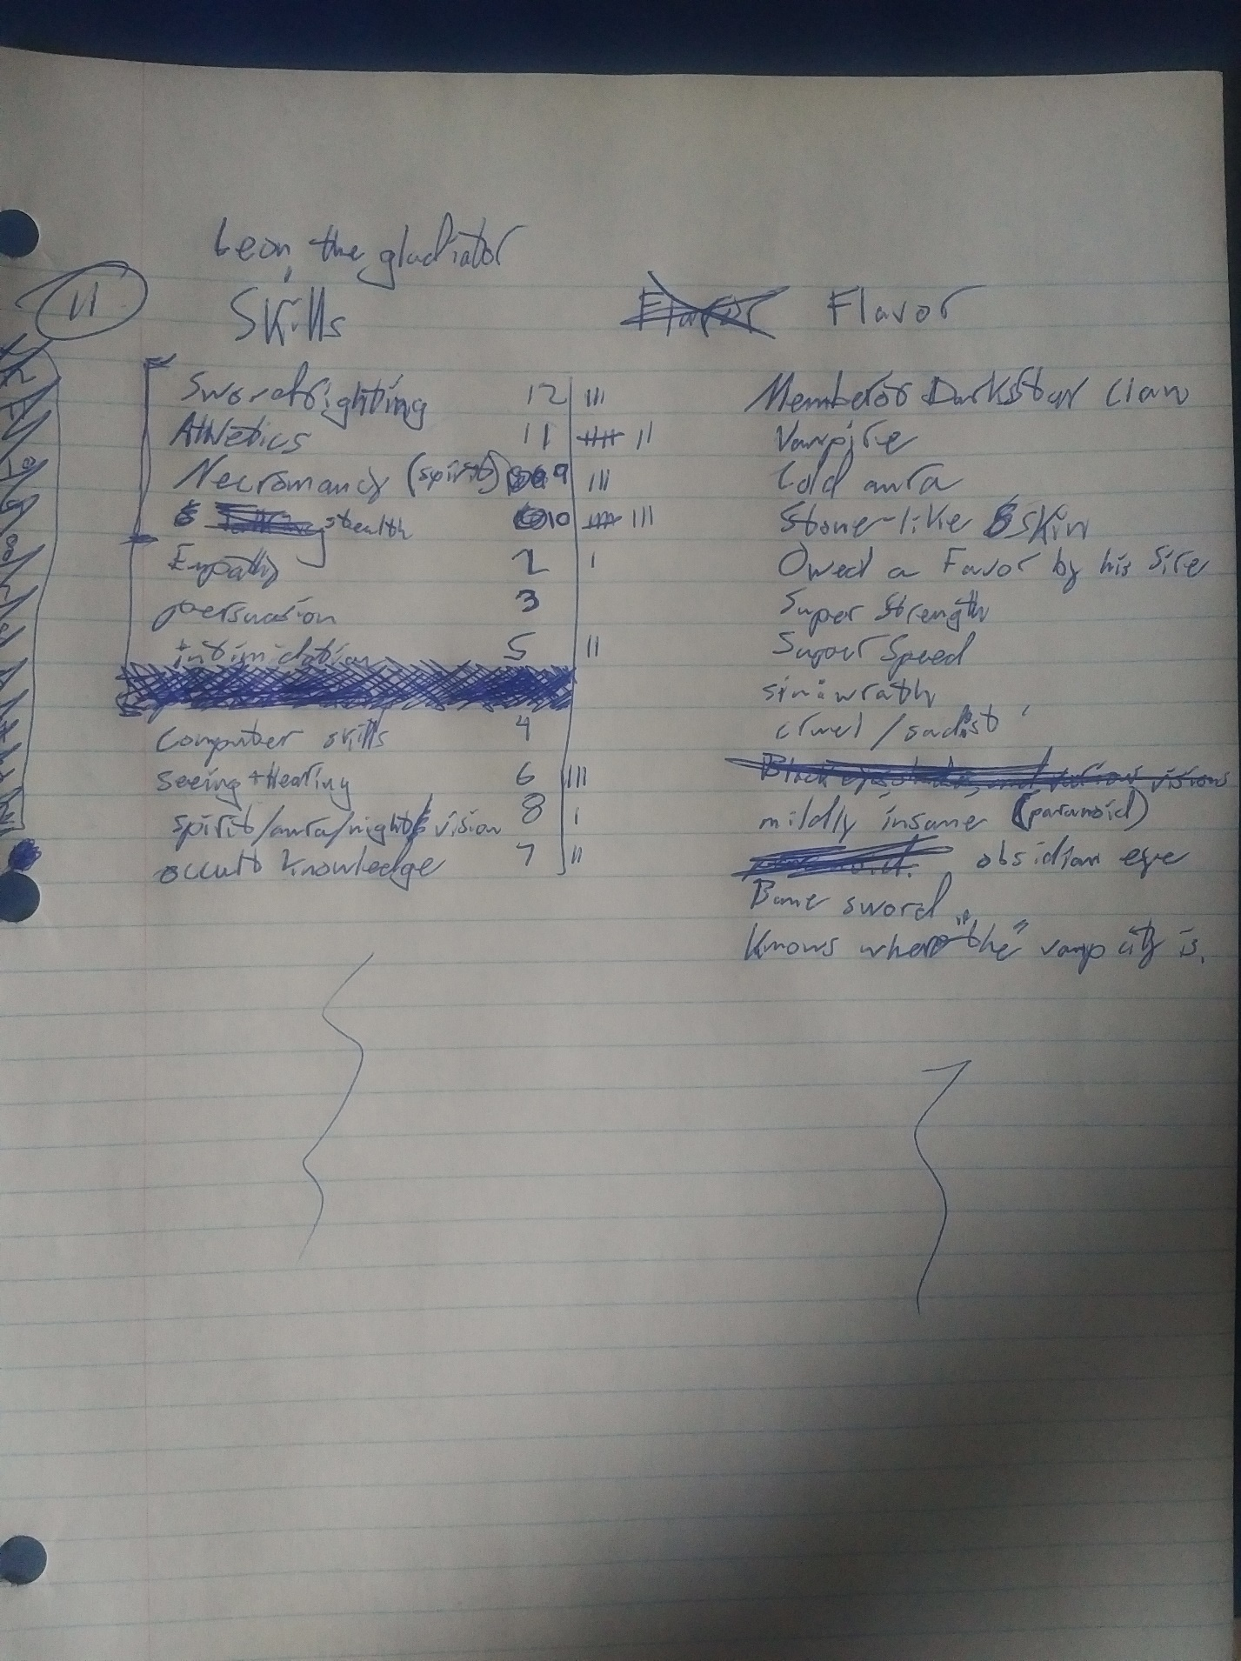

**Flavor:** Flavor describes anything a character knows, owns, has, or is. Its purpose is to make characters unique and interesting. Each piece of flavor is a description of an aspect of the character and nothing more. *Some examples of flavor are “recognizable facial scar”, “is a centaur”, “owns a spaceship”, “is a leper”, “rich”, “is blind”, “haunted by past crimes”, “brother to the king”, “mayor’s wife”, “has a reputation for beating priests”, “strong”, “carries a gun”, “knowledge of the occult”, “educated in chemistry”, and “sexy”.* Flavor should note how your character differs from the norm. Minute or mundane pieces of flavor just clutter the character sheet.

1. The storyteller announces the setting of the story. *Retro-futuristic, medieval, sword and sorcery, the high seas, steampunk Victorian England, modern America, the wild west, and warring kingdoms era China are all good settings.*
2. Someone in the group, defaulting to the storyteller, decides what type of group the characters will be. *The group could be a band of college kids in a retro-futuristic setting, a mercenary band in a medieval setting, or interstellar refugees in a futuristic setting.*
3. Define your character’s role within the group. *A group of college students might consist of a jock, a nerd, a theater major, and a trust fund baby.*
4. State one of your character’s strongest motivations. Characters that aspire to sit around and do nothing are boring. *Protecting a charge, conquering the galaxy, faithfully serving a ruler, getting revenge, and wooing a lover are a few examples of decent motivations.*
5. Add flavor to your character. This can be whatever you want it to be but remember it is subject to storyteller veto. *Typically, things that grant too much social power like “emperor of the galactic federation” and things that trivialize important challenges like “cant loose a fight” or “can’t be lied to” get vetoed.*
6. Define something your character wants from another character. Getting it should not be trivial. *Love, respect, a kidney, child custody, acceptance, and a job all fit the bill.*
7. Relate your character to another character personally or professionally. The person playing that character must agree to it. *Relationships can be husband-wife, brother-sister, parent-child, worker-boss, or all manner of other things.*
8. Give another character flavor. Try to add flavor that you think fits that character. This can be vetoed by the storyteller or a majority vote.
9. The storyteller adds some flavor to your character. This is an appropriate time to connect characters to the story distributing quests, interesting items, and prophesies. You can also connect the players to significant locations, characters, organizations, and events within the setting.
10. Repeat steps 3 through 8 a couple times. The order doesn’t matter much.

**Skills:** A skill is something a character can do. A skill consists of a name and two numbers representing level and experience. *Some examples include “swordsmanship”, “intimidation”, “stealth”, “empathy”, “persuasion”, “lying”, “running”, “reading and writing”, “speaking Spanish”WHY IS THIS A SKILL THIS IS ALSO A FLAVOR, “seeing and hearing”, “fire magic”, and “computer hacking”.* Every character should be able to communicate and gather information. A good format for skills is “<name><level><experience tally>”.

1. Write down some things your character does that they are good at, average at, and bad at in roughly equal thirds. Choose the 11 most important of these. One or two of these should be special or even magical. The rest should be normal within the setting.
2. The skill levels for your first 11 skills are 2,3,4,5,6,7,8,9,10,11, and 12. Assign each to one of the skills you made in the previous step. All new skills begin with 0 experience.
3. Add descriptions to skills with unclear names. *For example, ambiguous skills like “wind reading” should be defined. Possible descriptions include “being able to read amazingly quickly” and “poetically named sense of the weather”.*
4. Add limitations to skills that are too powerful. *Skills like “telekinesis” are very open-ended and can be used to scramble peoples’ brains or move the sun around if you don’t add limitations.* Good limitations include limiting duration, strength, accuracy, uses per day, speed of use, a bunch I haven’t thought of or listed, and any combination of the above.
5. Have the storyteller review your character’s skills. If a skill doesn’t fit your character or the setting revise it until it does. If your storyteller asks you to add limitations or descriptions to your skills, do it.

**Skill Points:** Skill points are used to buy skills for a character after character creation. Each character starts with 10 skill points. At the end of each storytelling session each character in the story gets 1 skill point. Both the starting and income values for skill points can be overwritten by the storyteller.